Capstone Task Day 02
Name: Ibrahim Shnouda
Group: IoT701-A
Facilitator: Eng.Ehab Elsayed
------------------------------------------------------------------------------------------------------
Tasks:
1. running
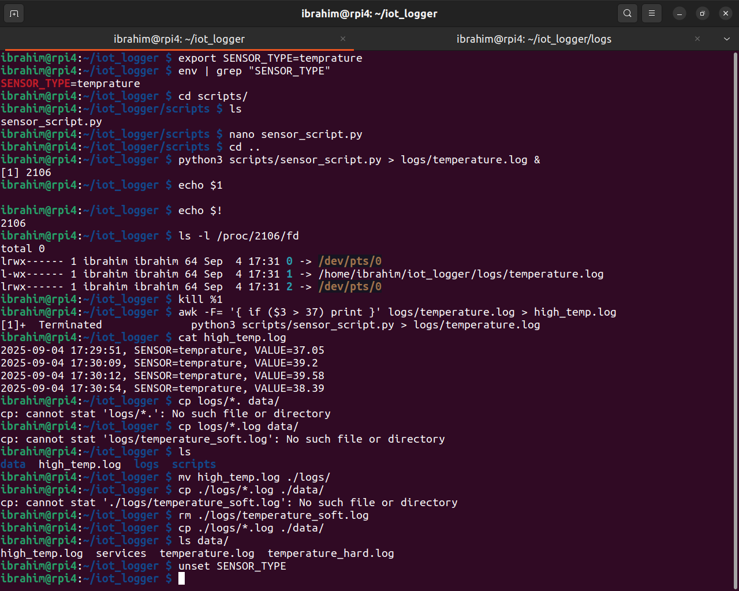
2.History
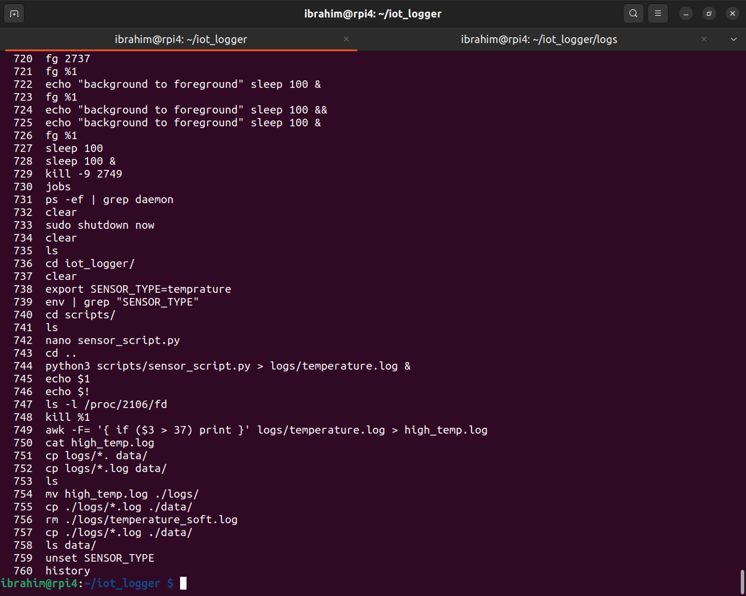

3.Script
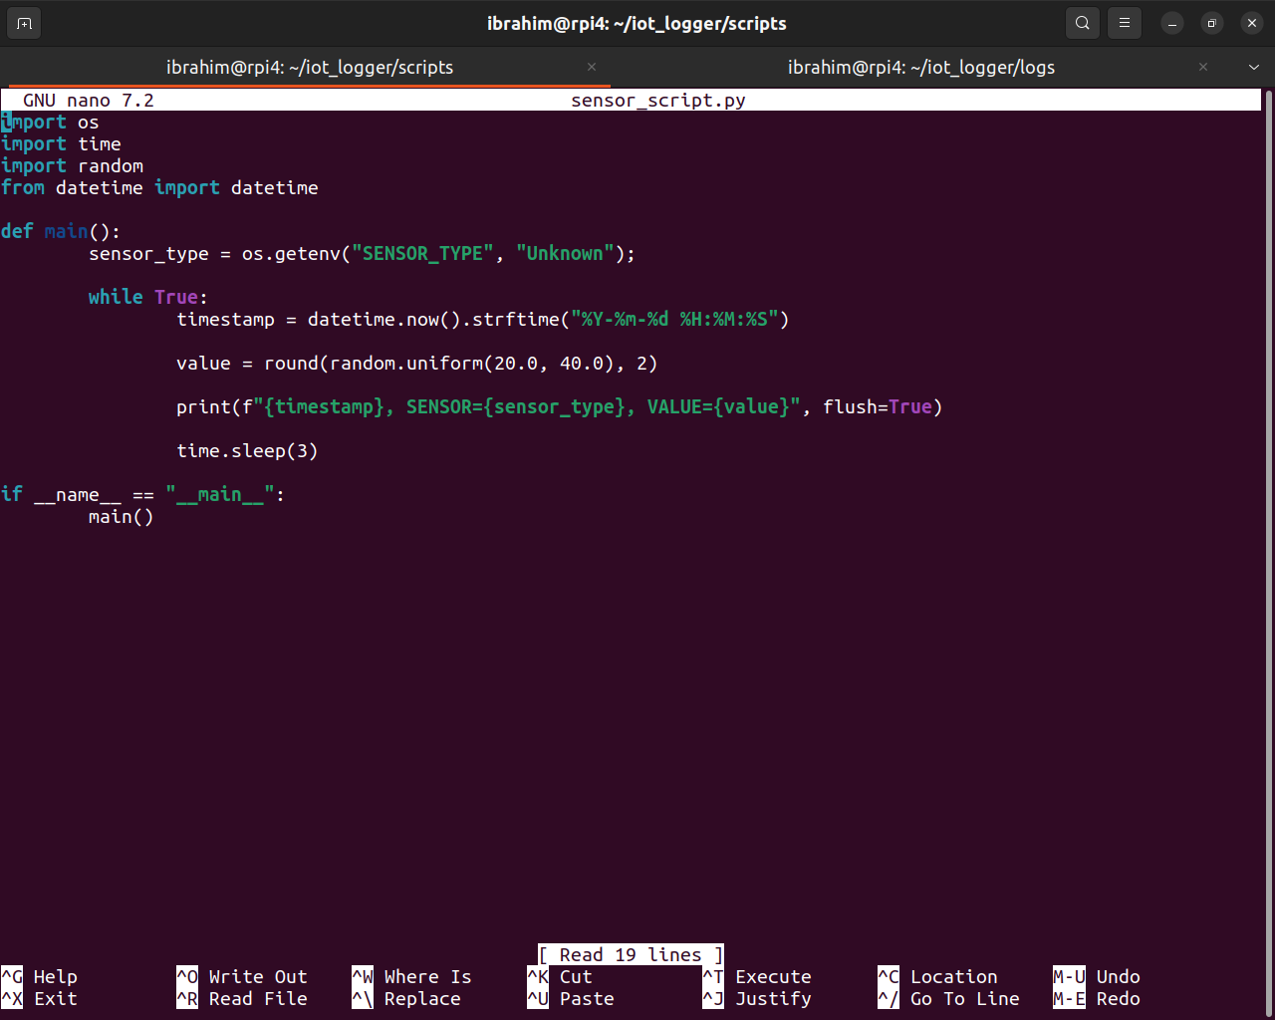
4.Challenge – Pipes & FD inspection :

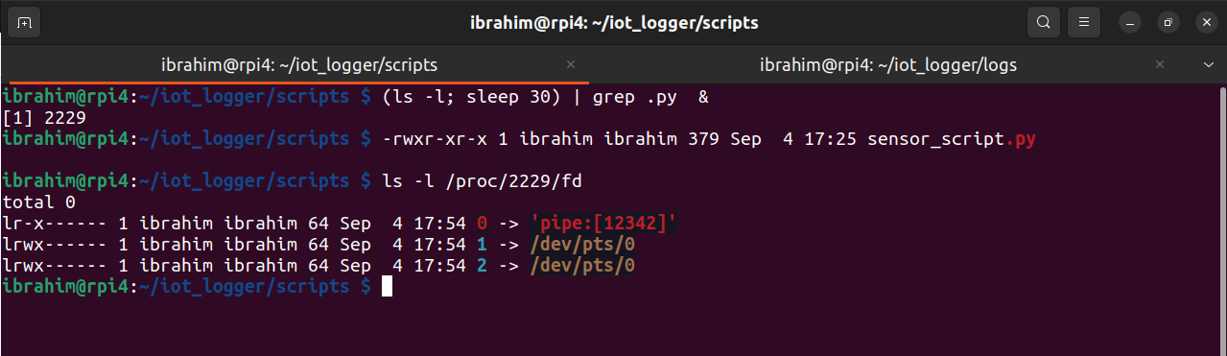

Open-Ended Questions:
1.in shell single quotation differ then double quotation
1.1. ‘’: any thing between ‘’ as string no variable replacement
1.2 “”: special case of deal with line if contains vars

2. [ -f filename ] vs [ -d dirname ]
2.1.[ -f filename ]: check file is exist or not
2.2.[ -d dirname ]: check directory is exist or not

3. any process in linux has a file descriptor (df) refer to output, input, error
stdout 1 for output
stderr 2 for error
stdin 0 for input
IO redirection: let us to take example about terminal if you write prompt such that : echo “hello sic” the default output in terminal stdout 1 for printing in terminal, we can change from terminal to any file we need such that:
echo “hello sic” > sic.txt

another example if you write any prompt in terminal need input the default input dierction will take from terminal, but what if we need the program to take its input from another file such that :
echo < sic.txt

4.calculator:

